福特公司Lihua Chen博士讲座

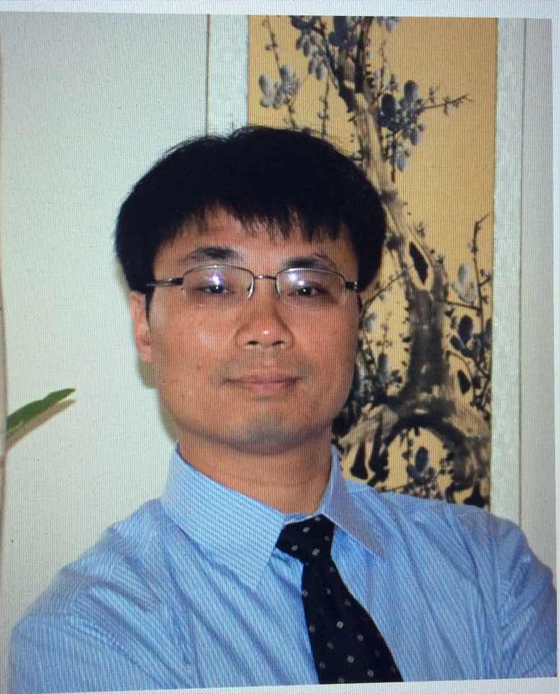
讲座题目：
Sustainability - Electrification & Power of Choice
讲座时间：2016年7月7日上午10:30
报告地点：电机工程楼201室

专家介绍：
Lihua Chen received his Ph.D degree from Michigan State University. He joined Ford Motor Company in 2008 and currently works as a Power Electronics Technical Expert technically leading traction inverter design for Ford next generation hybrid electric vehicles. From 1999 to 2002, he was with Argonne National Lab, Chicago, as a visiting Researchers, and before that, he has worked as an Assistant Professor for three and one half years in China. He has published 100+ technical papers and holds more than 10 US Europe and China patents. He also has given numerous technical presentations to IEEE conference, research institutes, universities and various companies.

欢迎广大老师和学生光临！

